Graded Unit 2
12/06/2026
sIMPLY rUGBY EVALUATION
Raven Louiz Mortega

Table of Contents

Table of Figures 2
System Overview 4
Evaluation of the Final System 5
Functional Requirements 5
Non-Functional Requirements 8
Strengths of the Solution 9
Weaknesses of the Solution 9
System Recommendations 10
Coding Recommendations 11
Changes Made During Development 12
Changes in Project Plan 12
Design Modifications 15
Implementation Modifications 31
Database Modifications 31
Additional Modification in Architectural Features/Components 33
MVC Architecture with Access Control 34
Reflection 35
Figures 37

Table of Figures
Figure 1 Original Use Case Diagram 15
Figure 2 Actual Use Case Diagram 16
Figure 3 Original Interface Design for All Senior Players 17
Figure 4 Original Interface Design for All Player Profile 17
Figure 5 Actual Interface Design for All Senior Player 18
Figure 6 Actual Interface Design for Player Profile 18
Figure 7 Actual Interface Design for Player Profile 2 19
Figure 8 Original Class Diagram 20
Figure 9 MVC Architecture with Access Control 34
Figure 10 37
Figure 11 37
Figure 12 37
Figure 13 38
Figure 14 38
Figure 15 38
Figure 16 38
Figure 17 39
Figure 18 39
Figure 19 39
Figure 20 39
Figure 21 39
Figure 22 40
Figure 23 40
Figure 24 40
Figure 25 40
Figure 26 41
Figure 27 41
Figure 28 41
Figure 29 42
Figure 30 42
Figure 31 42
Figure 32 43
Figure 33 44
Figure 34 44
Figure 35 45
Figure 36 45
Figure 37 46
Figure 38 46
Figure 39 48
Figure 40 Parent 48
Figure 41 Coach 48
Figure 42 Coach and Parent 49
Figure 43 Fixture Secretary 49
Figure 44 Section Secretary 50
Figure 45 Senior Player 50
Figure 46 Club Chairperson 51
Figure 47 Membership Secretary 51
Figure 48 51
Figure 49 52
Figure 50 52
Figure 51 52
Figure 52 52
Figure 53 53
Figure 54 53
Figure 55 54

System Overview
Simply Rugby is a rugby club based in Glasgow. The club supports players across multiple age groups and requires an efficient method of managing its administrative and rugby-related activities for its members and players. To address this need, the Simply Rugby Club Management system was developed as web-based application to allow multiple users to access the system in real-time and promote the club through online presence. It provides a centralised platform for managing member registration, training sessions, match fixtures, player profiles, injury record, training attendance, and player skills and performance records.
The system was designed for use by club administrators, club secretaries, coaches, senior players, parents of junior players and public. Which provide access to features relevant to their role.
The application was developed using Object Oriented Programming Principles(OOP) with PHP and MySQL for database management. A Singleton design pattern was used to maintain a single database connection throughout the application, while transactions were used to preserve data integrity when performing multiple related database operations.
The interface was developed using Tailwind CSS and Flowbite components, while Chart.js and Flowbite ApexCharts for data visualisation.
JavaScript was utilised for client-side functionality, and Composer was used for package and dependency management. The system follows the Model-View-Controller (MVC) architectural pattern and also incorporates both Role-Based-Access (RBAC) and Attribute-Based Access Control to ensure secure access to authorised records and features.
The system is currently hosted online and can be accessed through a web browser in range of devices. A live version of application is available at https://simply-rugby.infinityfree.io/

Evaluation of the Final System

Functional Requirements
Description | Actual Implementation | Evidence
The system shall allow a user to register | Achieved | See Figure 10
The system shall allow coach/parent with multiple children to view their children details through single login account only | Achieved | See Figure 11 and 12
The system shall require registered players to be validated by membership secretary before activation. | Achieved | See Figure 13
The system shall assigned players to one squad as per criteria. | Achieved | See Figure 14
The system shall allow user to login with valid credential | Achieved | See Figure 15
The system shall allow authorised users to manage player profile | Achieved | See Figure 16
The system shall allow registered users to manage their account details | Achieved | See Figure 17
The system shall allow members except junior players to upload their own profile image. | Not Implemented. Dummy images were used as placeholder for adult members | N/A
The system shall allow players to progressed to another squad as they age. Must be validated by membership secretary and moved after season ends. | Not Implemented due to technical constraints | N/A
The system shall archive player’s data from former squad when promoting to another squad and 5 years after they left the club. | Not Implemented due to technical constraints | N/A
The system shall allow authorised users to manage match information | Achieved | See Figure 18,19,20, 21, and 22
The system shall allow authorised users to manage training session event | Achieved | See Figure 23,24,25
The system shall allow authorised users to manage record player’s training attendance | Achieved | See Figure 26
The system shall allow authorised users to manage training activities | Achieved | See Figure 27
The system shall allow authorised users to manage training skills undertaken | Achieved | See Figure 28
The system shall allow authorised users to manage training injuries | Achieved and include match injuries | See Figure 29
The system shall restrict access to player data to authorised personnel only. Ensure only essential information is displayed when necessary | Achieved | See Figure 30
The system shall allow authorised users to select team for a match. | Achieved. Coach and Club Chairperson has access to select player match lineup | See Figure 31
The system shall store guardian details for junior players including contact and relationship information | Achieved | See Figure 32
The system shall send email or SMS to players regarding a training session or match. | Partially Achieved. Email notifications were implemented. However, due to the limited trial of the email service, the functionality could not be fully demonstrated in the test cases. Sample template was provided instead. | See Figure 33
The system shall allow authorised users to send information/communication to members | Achieved but unable to provide evidence for test case due to limited trial of email service. Sample template was provided instead. | See Figure 34
The system shall generate a visual report/chart analysis to display the player’s skills and performances | Achieved | See Figure 34 and 36
The system shall restrict access to junior’s data to public. | Achieved. Only senior’s name position, height and weight, and matches are displayed in public view. | See Figure 37
The system shall obtain consent from parent/guardians of junior player every season to renew membership. | Partially Achieved. Consent is obtained, but squad renewal is not implemented. Only declined renewals update the player's status to inactive and sets squad players end date. | N/A
The system shall prompt parents of junior player and senior players at least 2 weeks before season ends to renew membership. | Achieved but prompts 1 month before. | See Figure 38
The system shall allow parent to view their child’s information | Achieved | See Figure 39
The system shall allow users who has multiple roles to access authorised data through appropriate navigation control | Achieved | See Figure 40,41,42,43,44,45,46, and 47
The system shall allow senior player to login to their account | Achieved | See Figure 45
The system shall not provide direct login for junior players | Achieved. Login is given to primary guardian | See Figure 40
The system shall prompt senior player and parents of junior members to respond to match or training session with their availability status. | Not achieved due to time constraint | N/A
The system shall allow authorised user to manage members accounts. | Achieved | See Figure 48 and 49
The system shall support search function | Achieved | See Figure 50
The system shall allow parents to apply for coach. | Achieved | See Figure 51,52, and 53
If the parent is an existing coach, the system shall detect it | Achieved | See Figure 11 and 12
The system shall allow player to view their own match history | Achieved. Includes training attendance history | See Figure 54
The system shall store SRU registration number for all playing members | Achieved | See Figure 55

Non-Functional Requirements
Description | Actual Implementation
The system must have sufficient security features | Achieved
The system shall collect and store only data necessary for its intended purpose. | Achieved
The system shall ensure personal data is retained only for as long as necessary and securely deleted thereafter. | Not Implemented
The system shall ensure users can access only authorized functions, data, or fields based on roles | Achieved
The system shall be easy to maintain | Achieved
The page shall load within 2-3 seconds | Achieved
The system shall be easy to use and navigate | Achieved
The system shall be compliant in GDPR | Achieved
The system shall support skeletal loading | Not Implemented
The system shall support dark mode | Partially Achieved. The system automatically matches the device’s current theme settings. However, although a theme toggle was implemented, this feature only affects few components because it was not fully integrated across the system.
The system shall validate user inputs | Achieved
The system shall ensure all data imported into the system must match defined validation rules | Achieved
The system shall support cross-browser compatibility | Achieved
The system shall be responsive across different ranges of device | Achieved
The system shall ensure text and interactive components to meet specific contrast ratios | Achieved
The system shall use approved colour palettes, ensuring consistency in brand, look, and feel across all screens. | Achieved
The system shall use consistent colour schemes for navigation and design elements to improve user experience. | Achieved
The system shall allow administrators to search, query, and retrieve logs for a specific user within 10 seconds | Achieved. Data retrieves within 2 seconds
The system shall have 99.99% uptime | Partially Achieved. Website remained accessible throughout testing period. Long-term 99% uptime could not be verified
The system shall validate data before submitting | Achieved
The system shall detect and prevent data duplication. | Achieved
The system shall display error or success message. | Achieved
The system shall be compatible with different operating system | Achieved

Strengths of the Solution
General strengths of the actual implementation are listed as follows:
- The system has implemented sufficient data security using access control which protects the integrity of the system. The integration and combination of Role and Attribute Access Control (RBAC and ABAC) restrict users to only records and pages they are authorised. Any attempt to tamper the URL using Insecure Direct Object Reference(IDOR) where the object exposed in the URL is modified by a user and Force Browsing by directly accessing hidden pages were effectively managed using combination of RBAC and ABAC which redirects user to a 403 HTTP status page. This page tells the user they are unauthorised to access this record. In addition, accessing non existing page redirects user to 404 page.
- The database is well normalized.
- Duplicate member, login, address, player allergies, player health condition, and doctor records are well managed.
- Reusable helper functions, PHP includes, and private methods improve the programming efficiency.

Weaknesses of the Solution
- Failure to fully achieve the player renewal feature which allows player to continue their membership and re-validated for junior players.
- System design and planning could be improved.
- Other functional and non-functional requirements such as progressing to another squad, dark mode, skeleton loading and etc, were partially or not fully met due to technical and time constraint.
- Registering another child player under an existing parent account prompts all parent’s details again instead of prompting for existing email or mobile number.

Recommendations for Future Development
Although the system meets most of its intended objectives, there are several future enhancements that could be implemented to further improve its features, functionality, usability, and overall performance. These recommendations are divided into two sections:

System Recommendations
This section outlines recommended features for future development.
- Dashboard Page- future development could introduce role-specific dashboards that provide users with summary of relevant information such as upcoming fixtures, training sessions, relevant statistics, and other club activities
- Activity Log – this system could be implemented to allow club admins particularly the Club Chairperson, to monitor important actions performed by other members within the system. This would improve transparency and identify unusual activity pattern.
- Parent Attendance Notifications – This feature was initially planned during the planning stage, however due to the limited time, this feature was removed. This feature allow system to automatically notify parents or guardians when a child is marked absent or present from a training session.
- Mobile Application – The current system could benefit from the development of a mobile application to improve portability, user engagement and accessibility. This will enable user to access the feature more conveniently, receive real-time notifications, and a possible communication feature between members, players and parents.
- Membership Renewal and Cancellation Management – future versions could support this feature allowing players to manage their membership.
- Season Management Functionality – This feature could be introduced to simplify the creation of new seasons, archive historical data and support transition between seasons.
- Player Position Recommendation Feature – future development could utilise player skill ratings to recommend suitable playing position based on individual’s skills and performance data. This will be beneficial for coaches in identifying suitable position for players.
- Calendar Integration – external calendar platforms such as Google Calendar could allow uses to automatically synchronise training and match sessions.

Technical Recommendations
This section focuses on technical improvements of the application's architecture, maintainability, performance, and security.
- Laravel PHP Framework – Although the project was developed using PHP, future projects could benefit from Laravel framework to simplify application development.
- Optimised Data Retrieval – During the development of match management functionality, all match records were initially retrieved before applying validation and filtering.
- Improved Use of Front Controller –During the development, accessible child records were loaded and stored throughout the system using the Controller class(front controller). Future development could extend this approach by centralising and caching user access permissions for their accessible squad, players, and section. This would greatly reduce repeated validation checks and database queries of other controllers which may result to improved performance, consistency and maintainability.
- Improved Date Handling – Date input values could be directly formatted using the form rather than repeatedly formatting dates after user input.
- More Consistency in Naming Conventions – Consistency in variable and form field naming conventions would allow POST data to be processed more efficiently.
- Enhanced Form Validation Helper – To complement the recommendation above, more comprehensive formValidator class could be implemented across the entire system to centralise validation logic and error message display, and to reduce code duplication. Consistent naming conventions would enable validation rules to be applied more effectively.
- Comprehensive Testing – The system could incorporate automated unit testing and other testing method to validate system functionality more efficiently. This would reduce time required for manual testing of user input.
- Error Logging – An error logging system could also be implemented to record system errors to identify and resolve errors easier.

Changes Made During Development

Changes in Project Plan
This section will discuss the modifications in original project plan including changes in project schedule and software resources.

Project Schedule
While the original project plan established a clear schedule for the project, most activities took longer than expected due to some issues needing resolve and additional tools/resources were introduced during development. The table below illustrates the original project plan including the estimated duration allocated to each activity.
WBS Number |  |  | Task name / Title | Planned start date | Planned end date | Duration (hours) | Predecessor
1 | Planning |  |  | 16/03/2026 | 16/04/2026 | 79
1.1 |  | Analysis |  | 16/03/2026 | 30/03/2026 | 38
1.1.1 |  |  | Review of Project Brief | 16/03/2026 | 16/03/2026 | 7
1.1.2 |  |  | Research Similar System | 18/03/2026 | 20/03/2026 | 8 | 1.1.1
1.1.3 |  |  | Prepare Client Interview | 20/03/2026 | 21/03/2026 | 4 | 1.1.2
1.1.4 |  |  | Project Concept Meeting | 23/03/2026 | 23/03/2026 | 7
1.1.5 |  |  | Conduct Client Interview (Project Concept Meeting) | 23/03/2026 | 23/03/2026 | 3.5 | 1.1.3
1.1.6 |  |  | Identify Functional Requirements | 23/03/2026 | 26/03/2026 | 7.5 | 1.1.5
1.1.7 |  |  | Identify Non-Functional Requirements | 26/03/2026 | 27/03/2026 | 4 | 1.1.6
1.1.8 |  |  | Develop Project Plan | 27/03/2026 | 28/03/2026 | 4 | 1.1.7
1.1.9 |  |  | Analysis Stage Complete | 30/03/2026 | 30/03/2026 | 0 | 1.1.8
1.2 |  | Design |  | 30/03/2026 | 16/04/2026 | 41 | 1.1
1.2.1 |  |  | Initial Project Plan Meeting | 30/03/2026 | 30/03/2026 | 7
1.2.2 |  |  | Create UML Diagrams | 30/03/2026 | 03/04/2026 | 15 | 1.2.1
1.2.3 |  |  | Database Design | 03/04/2026 | 07/04/2026 | 14 | 1.2.2
1.2.4 |  |  | Design User Interface | 07/04/2026 | 09/04/2026 | 12 | 1.2.3
1.2.5 |  |  | Design Stage Complete | 16/04/2026 | 16/04/2026 | 0 | 1.2.4
1.3 |  | Planning Stage Complete |  | 16/04/2026 | 16/04/2026 | 0 | 1.2.5
2 | Implementation |  |  | 16/04/2026 | 30/05/2026 | 107 | 1
2.1 |  | Set Up Coding Environment |  | 16/04/2026 | 16/04/2026 | 2
2.2 |  | Organise Folder Structure |  | 24/04/2026 | 24/04/2026 | 2 | 2.1
2.3 |  | Coding |  | 24/04/2026 | 23/05/2026 | 77 | 2.2
2.4 |  | Development Progress Meeting |  | 17/05/2026 | 18/05/2026 | 7.02
2.5 |  | Testing |  | 23/05/2026 | 25/05/2026 | 11 | 2.3
2.6 |  | Create Technical Documentation |  | 25/05/2026 | 29/05/2026 | 11 | 2.5
2.7 |  | Deployment |  | 29/05/2026 | 30/05/2026 | 4 | 2.6
2.8 |  | Implementation Stage Complete |  | 30/05/2026 | 30/05/2026 | 0 | 2.7
3 | Evaluation |  |  | 30/05/2026 | 12/06/2026 | 42 | 2
3.1 |  | Solution Requirements |  | 30/05/2026 | 01/06/2026 | 11
3.2 |  | Define Strength & Weaknesses |  | 01/06/2026 | 04/06/2026 | 8 | 3.1
3.3 |  | Future Recommendation |  | 04/06/2026 | 08/06/2026 | 7 | 3.2
3.4 |  | System Modification |  | 08/06/2026 | 10/06/2026 | 8 | 3.3
3.5 |  | Reflection |  | 10/06/2026 | 12/06/2026 | 8 | 3.4
3.6 |  | Evaluation Stage Complete |  | 12/06/2026 | 12/06/2026 | 0 | 3.5

Listed below are the changes made to the implementation stage project schedule during the development phase:
Activity | Schedule Adjustment | Reason
Set Up Coding Environment | Took longer than expected | The configuration and integration of Tailwind CSS and Flowbite continued during coding stage for 2 weeks.
Organise Folder Structure | Took longer than expected. Required a full working day | MVC framework was introduce and careful planning of file structure was required.
Coding | Took longer than expected. Last 2 weeks requires significant extra hours. | Additional time was required to learn and implement MVC architecture, routing, SQL queries, composer, RBAC, and an ABAC solution because RBAC alone is not sufficient for system access requirement. In addition, development was delayed because of MySQL database corruption issues. This requires several complete or partial database rebuild. As a result, database backup and restoration were performed multiple times. Lastly, some features were introduced to make the system more complete. As a result, coding stage took considerably longer than originally planned.
Development Progress Meeting | Completed as planned | Meeting schedule had a fixed date.
Testing | Started later than expected | Delays in coding phase and requires additional time to resolve minor issues.
Create Technical Documentation | Started later than expected and required to finish within 3 days | Most documentation images became corrupted and had to be recreated. Although backup copies were made, these also became corrupted, limiting the ability to produce comprehensive technical documentation.
Deployment | Took longer than expected. Required a full working day. | The original file structure was not fully compatible with the hosting environment, requiring changes to the folder structure.
Implementation Stage Complete | Took a day longer than expected but completed within the deadline | A one-day buffer was included to accommodate any delays

Changes in Software Resources
Several software resources originally identified in the project were replaced and supplemented during the development stage.
- MailerSend, as proposed email service from the original plan was replaced by Mailtrap due to recent update which removed features necessary for project development.
- Flowbite ApexChart was added for data visualization.
- Composer was added during the development to support third-party dependencies and PHP packages efficiently.

Design Modifications

Original Use Case Diagram
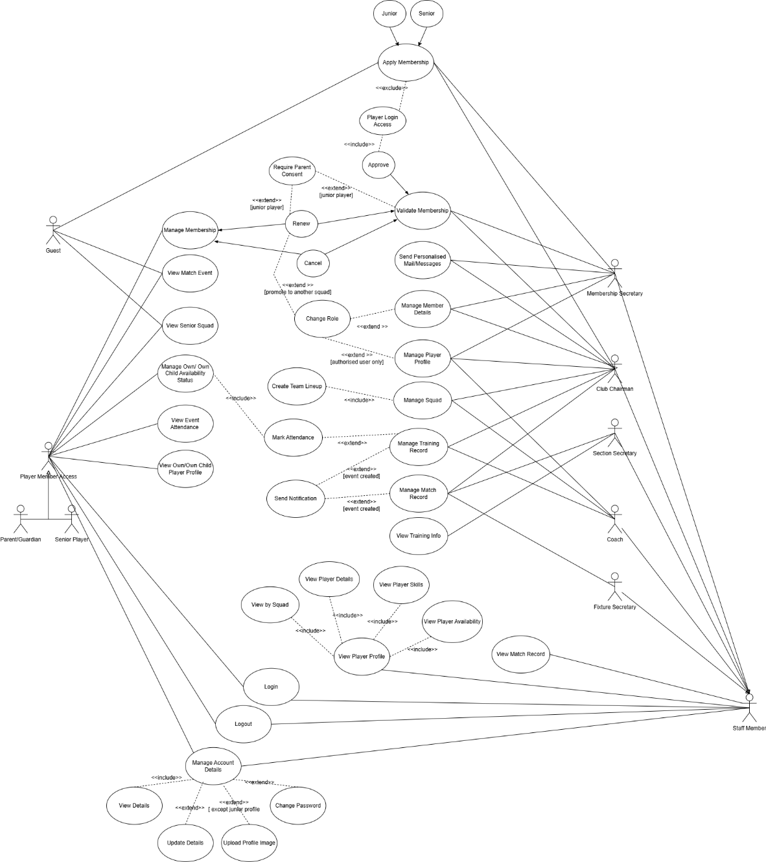
Figure 1 Original Use Case Diagram

Actual Use Case Diagram

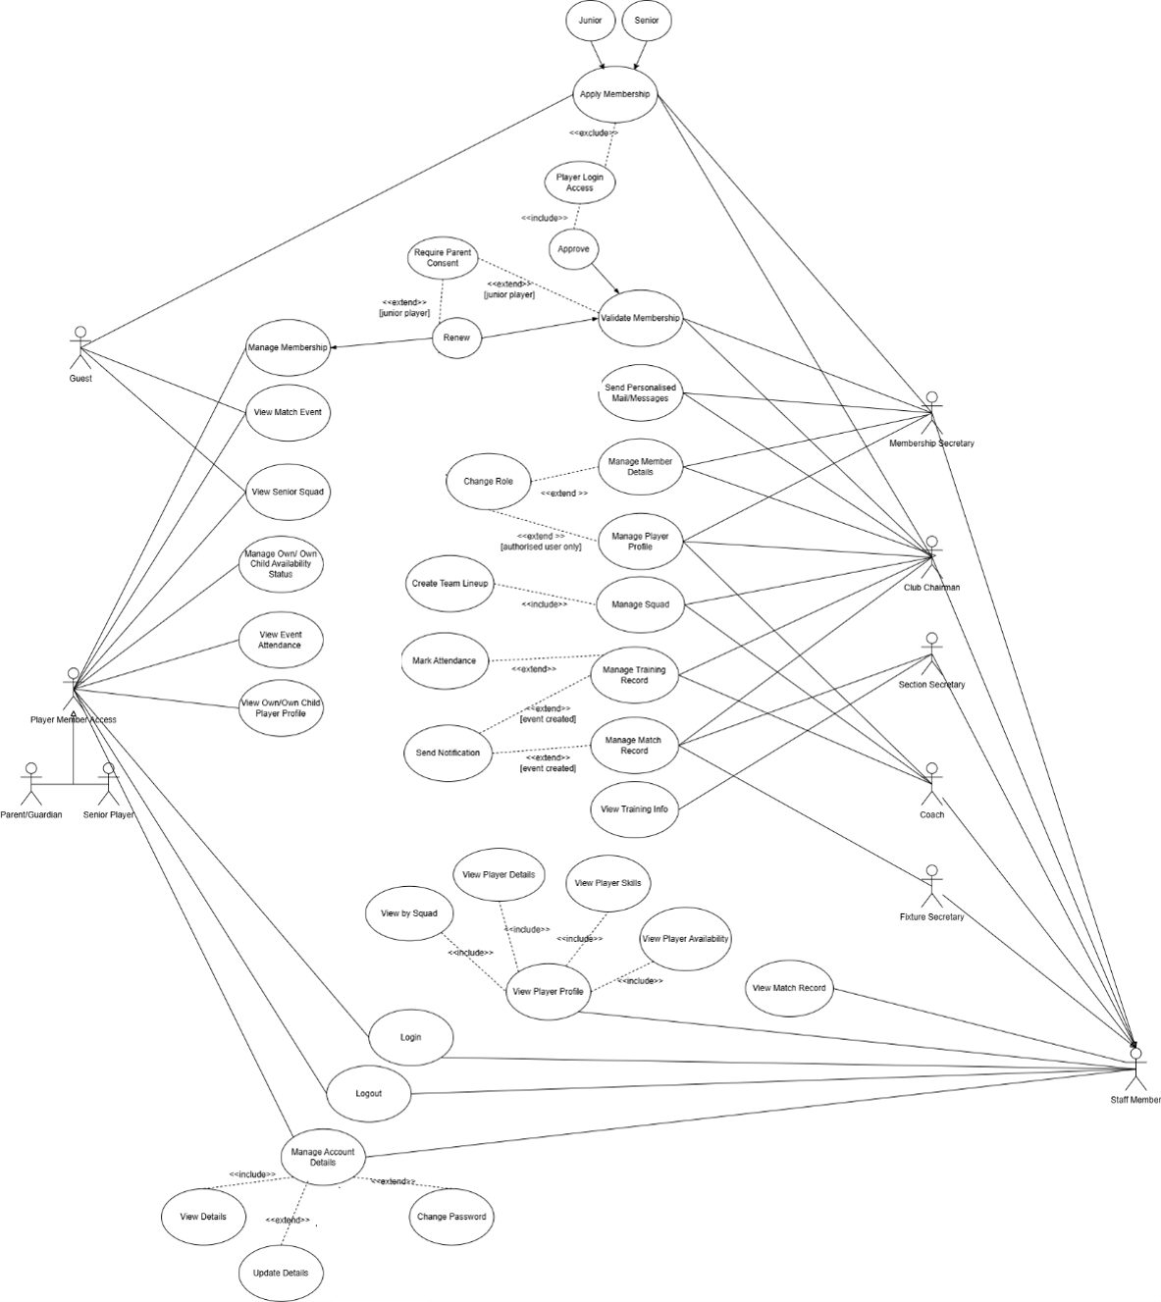
Figure 2 Actual Use Case Diagram

Original Interface Design
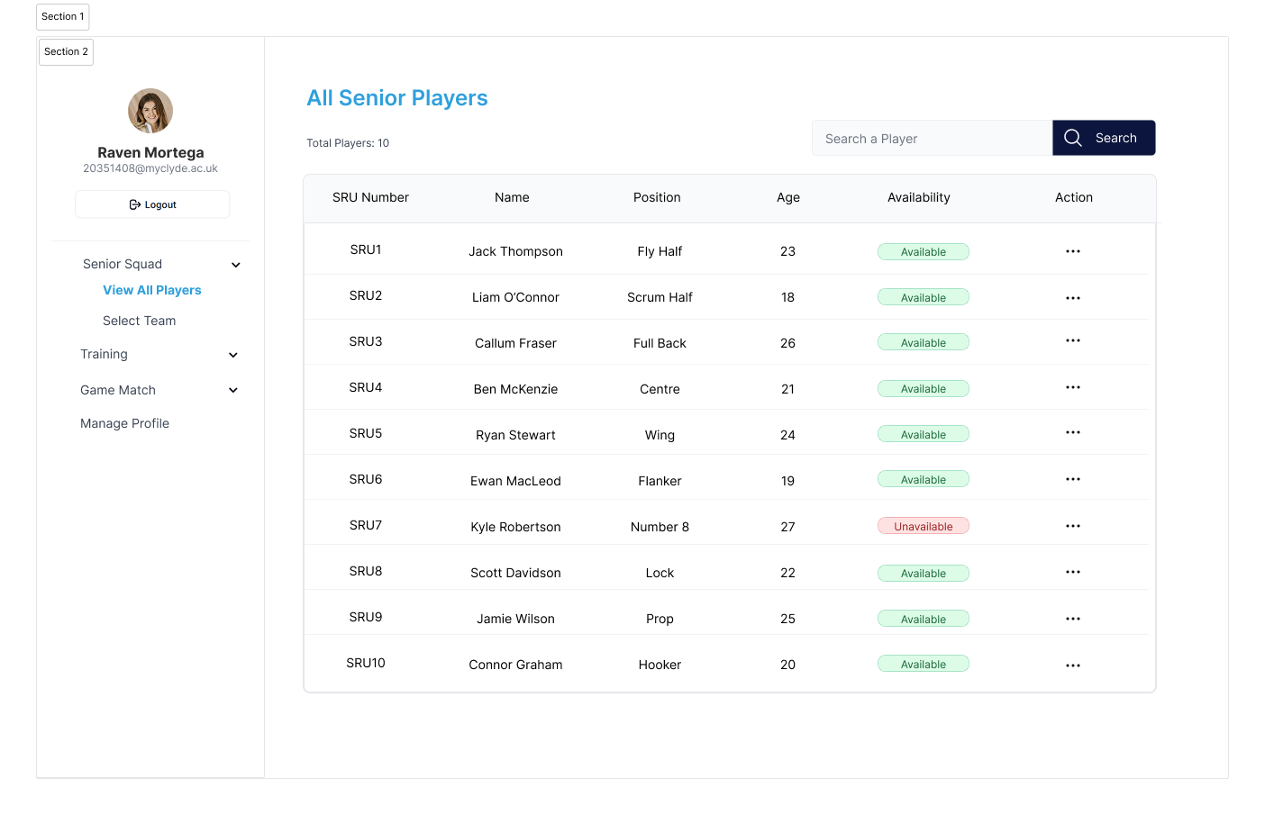
Figure 3 Original Interface Design for All Senior Players
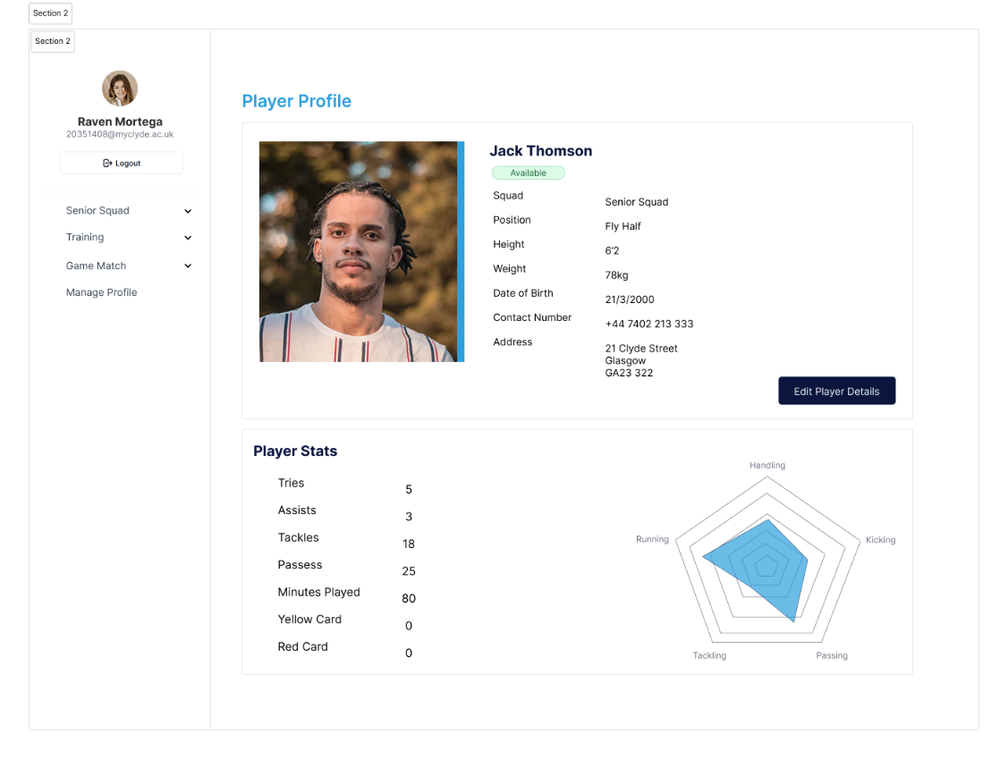
Figure 4 Original Interface Design for All Player Profile

Actual Interface Design
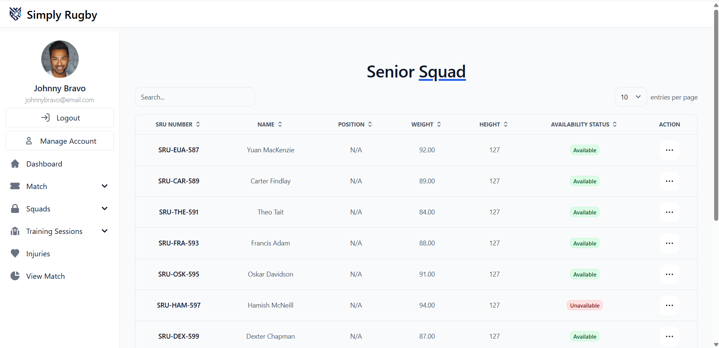
Figure 5 Actual Interface Design for All Senior Player

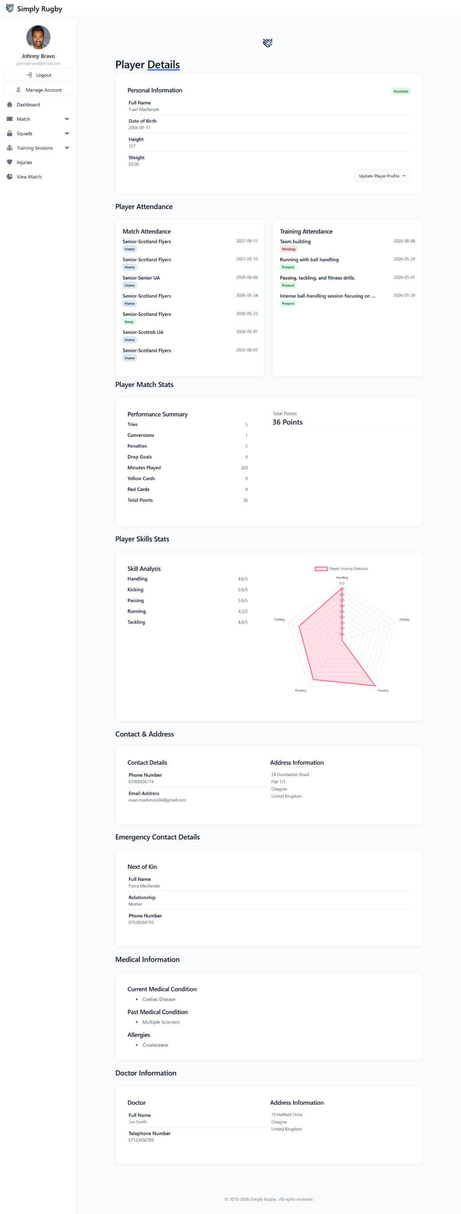
Figure 6 Actual Interface Design for Player Profile

Figure 7 Actual Interface Design for Player Profile 2

Original Class Diagram

Figure 8 Original Class Diagram

Updated Class Data Dictionary
Class Name | Definition
AccessControl | Responsible for controlling user access to system features and data based on their assigned role and permissions.  Inheritance:  - extends MemberController,  Attributes:  - array authorizedMatchIds – stores authorised match IDs for the current user.  Operations:  - __construct() – initialises authorised match IDs.  - getAuthorizedSquads() – gets role access for squads.  - getAuthorizedTraining() – gets role access for training session details.  - getAuthorizedMatches() – gets role access for match details.  - getAuthorizedInjury() – gets role access for injury records.  - getAccessPlayers() – gets junior players linked to a parent.  - getAccessSquads() – gets squads assigned to a coach.  - getAccessSections() – gets sections managed by a Fixture or Section Secretary.  - lineupParentAccess() – checks parent access to match line-ups.  - validateSquadAccess() – validates squad access and returns squad details.  - validateMatchAccess() – validates match access and returns match details.  - validateMemberAccess() – validates member access and returns member details.  - canViewPlayer() – checks if a user can access player details.  - canViewMember() – checks if a user can access member details.  - canViewMatch() – checks if a user can access match details.  - canViewSquad() – checks if a user can access squad details.
Address | Responsible for managing address information within the system.  Attributes:  - int address_id – unique identifier for an address.  - string line_1 – first line of the address.  - string line_2 – second line of the address.  - string city – city of the address.  - string postcode – postcode of the address.  - string country – country of the address.  Operations:  - __construct() – initialises address attributes with default values.  - getAddressDetails() – gets address details using the address ID.  - insert() – inserts a new address into the database and returns the address ID.  - getCountries() – returns a list of supported countries for address selection.
Application | Responsible for managing player applications and application-related operations.  Operations:  - __construct() – initialises the application object.  - updateStatus() – updates the status of an application.  - insert() – inserts a new player application.  - getPlayerApplications() – gets all player applications.  - getApplicationById() – gets an application using its ID.  - getPlayerApplicationDetails() – gets detailed information for a specific application
Attendance | Responsible for managing player attendance records for training sessions and matches.  Attributes:  - int training_session_id – stores the training session identifier.  - int member_id – stores the member identifier.  - string attendance_status – stores the attendance status of a player.  Operations:  - __construct() – initialises attendance details.  - insert() – adds a player to a training session attendance list.  - update() – updates a player's attendance status.  - getPlayersById() – gets all players assigned to a training session.  - getPlayerMatchAttendance() – displays a player's recent match attendance history.  - getPlayerTrainingAttendance() – displays a player's recent training attendance history.
Club | Responsible for storing the rugby club's information and contact details.  Attributes:  - string name – stores the club’s name.  - string line1 – stores the first line of the club address.  - string city – stores the club city.  - string zipcode – stores the club postcode.  - string country – stores the club country.  Operations:  - __construct() – initialises the club information with default values.
Doctor | Responsible for managing doctor information associated with player medical records.  Attributes:  - int doctor_id – stores the doctor's unique identifier.  - string doctor_name – stores the doctor's name.  - string doctor_tel – stores the doctor's telephone number.  - int address_id – stores the doctor's address identifier.  Operations:  - __construct() – initialises doctor details.  - insert() – adds a doctor record to the database and returns the doctor ID.
Guardian | Responsible for managing guardian information, player contacts, and guardian access details within the system.  Attributes:  - int guardian_id – stores the guardian identifier.  - int application_id – stores the application identifier.  - int member_id – stores the player identifier.  - int address_id – stores the guardian's address identifier.  - int contact_member_id – stores the guardian's member identifier.  - string first_name – stores the guardian's first name.  - string last_name – stores the guardian's last name.  - string relationship – stores the guardian's relationship to the player.  - string mobile_number – stores the guardian's mobile number.  - boolean is_primary – indicates if the guardian is the primary contact.  - boolean apply_coach – indicates if the guardian has applied to become a coach.  - string email – stores the guardian's email address.  - string access_level – stores the guardian's access level.  Operations:  - __construct() – initialises guardian details.  - checkGuardianApplicationExists() – checks if a guardian application already exists.  - insertGuardianApplication() – stores a guardian application.  - insertPlayerContact() – links a guardian to a player account.  - getPrimaryApplicationGuardians() – displays primary guardian details for an application.  - getSecondaryApplicationGuardians() – displays secondary guardian details for an application.  - getPlayerGuardian() – displays guardian details linked to a player.
Injury | Responsible for managing player injury records and injury-related information within the system.  Attributes:  - int player_injury_id – stores the player injury identifier.  - int injury_id – stores the injury type identifier.  - int member_id – stores the injured player's identifier.  - date injury_date – stores the date of the injury.  - date recovery_date – stores the player's recovery date.  - int training_session_id – stores the training session identifier.  - int match_id – stores the match identifier.  - string injury_status – stores the current injury status.  Operations:  - __construct() – initialises injury details.  - insert() – adds a player injury record.  - update() – updates an existing injury record.  - getAllInjuries() – displays all injury types.  - getPlayerInjuryId() – displays injury details for a specific injury record.  - getPlayerInjuries() – displays all injuries associated with a player.  - getAllPlayerInjuries() – displays all player injuries.  - getAllPlayerInjuriesBySquad() – displays player injuries for a specific squad.
Match | Responsible for managing match fixtures, line-ups, results, and player match statistics.  Attributes:  - int match_id – stores the match identifier.  - int squad_id – stores the squad identifier.  - string match_venue – stores the match venue.  - date match_date – stores the match date.  - string opposition_team_name – stores the opposition team's name.  - time kick_off_time – stores the match kick-off time.  - string result – stores the match result.  - string squad_name – stores the squad name.  - string section_name – stores the section name.  - int section_id – stores the section identifier.  Operations:  - __construct() – initialises match details.  - insert() – stores a new match fixture.  - update() – updates match details.  - updateMatchResult() – updates the match result.  - updatePlayerPosition() – updates a player's position in the line-up.  - createLineupFromSquad() – creates a match line-up from squad players.  - getLineup() – displays the match line-up and player statistics.  - delete() – removes a match fixture.  - getMatches() – displays match fixtures.  - getMatchById() – displays details for a specific match.  - getMatchHalfById() – displays match half information.  - saveMatchHalf() – stores or updates match half results and comments.  - getAllMatchStats() – displays a player's overall match statistics
MedicalInformation | Responsible for managing player medical information, including medical conditions, allergies, and doctor details.  Operations:  - viewAllCondition() – displays all medical conditions.  - viewAllAllergy() – displays all allergies.  - insertConditionApplication() – stores medical conditions for a player application.  - insertAllergyApplication() – stores allergies for a player application.  - copyToPlayerCondition() – copies application medical conditions to a player record.  - copyToPlayerAllergy() – copies application allergies to a player record.  - getPlayerAllergies() – displays allergies associated with a player or application.  - getPlayerConditions() – displays medical conditions associated with a player or application.  - getPlayerDoctor() – displays doctor details associated with a player or application.  - getDoctorAddressId() – displays the address details of a doctor
Member | Responsible for managing member information, membership status, and member-related operations within the system.  Attributes:  - int member_id – stores the member identifier.  - string first_name – stores the member's first name.  - string last_name – stores the member's last name.  - date dob – stores the member's date of birth.  - int address_id – stores the member's address identifier.  - string mobile_num – stores the member's mobile number.  - string membership_status – stores the member's membership status.  - string profile_image – stores the member's profile image.  - string email – stores the member's email address.  - string password – stores the member's password.  - array allNoLogin – stores members without login accounts.  Operations:  - __construct() – initialises member details.  - registerPlayer() – registers a player account.  - selectAllNoLogin() – displays members without login accounts.  - selectAll() – displays all members or members by role.  - validateInsert() – checks if a member already exists.  - insert() – stores a new member record.  - update() – updates member details.  - delete() – removes a member record.  - selectEmail() – displays a member's email address.  - selectIdByEmail() – displays a member ID using an email address.  - getMemberDetails() – displays detailed member information.  - getMembersByRole() – displays members assigned to a specific role.  - updateMembershipStatus() – updates a member's membership status.
Player | Responsible for managing player profiles, player statistics, and player-related records within the system.  Operations:  - insert() – stores a new player profile.  - generateSRUNumber() – generates a unique SRU number for a player.  - delete() – removes a player record.  - playerProfile() – displays a player's profile information.  - updateHistoryEndDate() – updates the end date of a player's squad history.  - insertPlayerMatchStats() – stores or updates player match statistics.  - updatePlayerProfile() – updates a player's profile details.
PlayerSkill | Responsible for managing player skill ratings and skill performance records.  Attributes:  - int player_skill_id – stores the player skill record identifier.  - int training_session_id – stores the training session identifier.  - int member_id – stores the player identifier.  - int skill_id – stores the skill identifier.  - string skill_name – stores the skill name.  - int skill_category_id – stores the skill category identifier.  - string skill_category_name – stores the skill category name.  - int coach_member_id – stores the coach identifier.  - int rating – stores the player's skill rating.  - string date_recorded – stores the date the skill rating was recorded.  Operations:  - __construct() – initialises player skill details.  - insertSkillRating() – stores a player's skill rating.  - calculateAverageRatingByCategory() – calculates the average skill rating for each skill category.  - getPlayerSkill() – displays a player's recorded skills and ratings.
PrivilegedUser | Inheritance:  - extends User  Attributes:  - array roles – stores the roles and permissions assigned to the user.  Operations:  - __construct() – initialises the privileged user object.  - getPrivilegedMember() – creates a privileged user and loads their details.  - initRoles() – loads the user's roles and associated permissions.
Role | Responsible for managing user roles and permissions within the system.  Attributes:  - array permissions – stores the permissions assigned to a role.  Operations:  - __construct() – initialises role permissions.  - getRolePerms() – loads permissions assigned to a role.  - insertMemberRoles() – assigns a role to a member.  - getRole() – displays all available roles.  - getRoleIdByMemberId() – gets the role assigned to a member.  - getRoleIdByName() – gets the role identifier using the role name.  This matches the style you've been using for your other class dictionary entries.
Skill | Manages skill categories and player skill information within the system.  Attributes:  - int skill_id – stores the skill identifier.  - string skill_name – stores the skill name.  - int skill_category_id – stores the skill category identifier.  - string skill_category_name – stores the skill category name.  Operations:  - __construct() – initialises skill details.  - getCategoriesAndSkills() – displays all skill categories and their associated skills.  - getSkillCategories() – displays all skill categories.
Squad | Responsible for managing squads, squad memberships, squad history, and squad-related information within the system.  Attributes:  - int squad_id – stores the squad identifier.  - string squad_name – stores the squad name.  - string section_name – stores the section name.  - string season – stores the squad season.  - date start_date – stores the squad start date.  - date end_date – stores the squad end date.  - int min_age – stores the minimum age for the squad.  - int max_age – stores the maximum age for the squad.  Operations:  - __construct() – initialises squad details.  - getMemberSquad() – displays squads assigned to a member.  - getRenewalReminder() – displays squad renewal information.  - getSquadCoaches() – displays coaches assigned to a squad.  - getSectionSquads() – displays squads managed by a section or fixture secretary.  - updateSquadStatus() – updates a member's squad status.  - getAllSquads() – displays all active squads.  - getSquadByName() – displays squad details using the squad name.  - getSquadById() – displays squad details using the squad ID.  - getNextSquad() – finds a suitable squad based on a player's age.  - insertSectionAdmin() – assigns a section administrator.  - insertSquadMember() – adds a member to a squad.  - listSquadPlayer() – displays players assigned to a squad.  - getSquadPlayers() – displays active players assigned to a squad.  - insertSquadHistory() – stores a player's squad history record.
Training | Manages training sessions, training attendance, and player skill assessments.  Attributes:  - int training_session_id – stores the training session identifier.  - int squad_id – stores the squad identifier.  - int coach_member_id – stores the coach identifier.  - string skills_activities – stores the skills and activities planned for the session.  - time start_time – stores the training start time.  - time end_time – stores the training end time.  - date date – stores the training date.  Operations:  - __construct() – initialises training session details.  - insert() – stores a new training session.  - update() – updates training session details.  - getTraining() – displays training sessions.  - getTrainingById() – displays details for a specific training session.  - hasSkillRatings() – checks if skill ratings have been recorded for a training session.  - deleteTraining() – removes a training session.
User | Handless user accounts, login credentials, and authentication-related operations within the system.  Attributes:  - int member_id – stores the member identifier.  - string email – stores the user's email address.  - string member_name – stores the member's full name.  - string password – stores the user's password.  Operations:  - findEmail() – checks if an email address exists in the system.  - findMemberLogin() – displays login details for a member.  - updatePassword() – updates a user's password.  - getCredentials() – displays a user's login credentials and account details.  - checkEmailExists() – checks if an email address is already registered.  - insertNewMemberLogin() – creates a new login account for a member.

Implementation Modifications
Several modifications in implementation stage includes:
- Match injuries were added although functional requirements originally specified injury management only for training sessions.
- Email notifications only implemented instead with both email and SMS notifications. This decision was made to avoid sending real SMS messages during development and testing.
- Membership renewal reminders changed from 2 week to 1 month before season end date to provide sufficient time for a player to respond.
- Profile images features were not developed due to time constraints because it would consume time to upload and create profile images for each member.
- Automatic player availability status functionality check for creating match and training session was not implemented due to limited testing data. As training sessions and matches are future events, player availability may change before the event occurs, making it difficult to effectively test this feature. This was particularly challenging especially for match event since a team must meet a minimum requirement of 15 available players before a match creation.

Database Modifications
Several changes were made to the database during development to improve the structure of the system and support the project requirements.
To reduce data duplication and improve database normalization, allergies and medical conditions were separated into their own tables and linked using junction tables. This allows a player or application to have multiple allergies and medical conditions without storing duplicate information.

New Tables Created:
- allergy
- medical_condition
- application_allergy
- player_allergy
- application_condition
- player_condition
- squad_member
- section_admin

Tables Renamed
- Login → logins

Member Table
- Removed sru_number
- Added email
- Removed default for role
- Removed default for junior

Player Profile Table
- Added sru_number
- Removed allergies
- Removed current_medical_condition.
- Removed medical_history.

Application Guardian Table
- Added email
- Added apply_coach

Database Normalisation
- Normalised allergy data into junction tables.
- Normalised medical condition data into junction tables.
- Reduced duplicated medical information.

Login and Authentication
- Added email to the member table.
- Modified authentication structure to use member email details rather than storing email separately in the login table.

Medical Information
- Introduced many-to-many relationships for allergies.
- Introduced many-to-many relationships for medical conditions.
- Added support for current and past medical conditions through condition_status.
- Removed text-based storage of allergies and conditions.

Match Management
- Added pending option to match results.

Additional Modification in Architectural Features/Components
- Implemented an MVC architecture without using a framework to gain better understanding of MVC design pattern while allowing improved code organisation and better file management.
- Incorporated the Singleton pattern to manage single shared database connection throughout the application and to allow PHP PDO transaction.
- PHP PDO transactions were implemented to allow database operations to be rolled back if an error occurs. This allows repeated testing without manually deleting test data ensuring data integrity and prevent data duplication for implementation and deployment.
- The system also implements a combination of Role-Based Access Control (RBAC) and Attribute-Based Access Control (ABAC) to ensure secure access to system resources since some roles have additional access restrictions based on their assigned attributes. Such as a coach are authorized to retrieve records of their own squad.

MVC Architecture with Access Control
The system follows a Model-View-Controller (MVC) architecture combined with Role-Based Access Control (RBAC) and Attribute-Based Access Control (ABAC). This diagram illustrates how user request interacts with the Views (web page) and are processed by Router, which perform routing and initial access validation of user permissions before sending the request to appropriate controller. Controllers then handle the request and interact with Auth Component to perform additional authorisation check to enforce RBAC rules. Furthermore, the requests are validated by AccessControl model which communicates and returns only accessible data based on their assigned attributes. This enables the enforcement of ABAC by restricting access of user to resources they are authorised to manage. The Models request the data from the Database which are then returned to Controller and rendered to appropriate View.
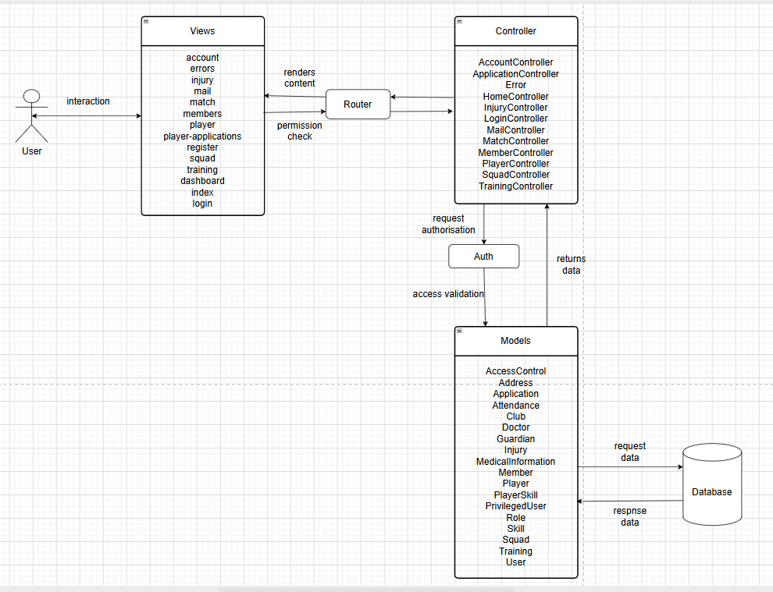
Figure 9 MVC Architecture with Access Control

Reflection
Throughout the project, I have developed range of technical skills and gained valuable knowledge in software development, project management, and self-discipline.
During the planning stage, I have improved my database design skills compared to my previous project. I developed a better understanding of database normalisation and applied this when designing the system’s database structure. I was able to create a well- structured database with clear understanding of relationships between each table.
For the implementation stage, I have improved my SQL skills especially with JOIN statements. As the system became more complex, I gained a better understanding of how relational database tables interacts, and retrieve, update, insert or remove data in a using SQL query. I also significantly improved my PHP programming skills by applying object-oriented programming approach, developing reusable classes and methods, and implementing features using MVC architecture. In addition, I improved my ability in organising project files by creating a more structured file hierarchy using the MVC framework. This helped me separate the UI, logics and database operation making the system easier to maintain.
During this stage, multiple problems, bugs and unexpected challenges were encountered that requires effective solution. These includes adoption of new software/technologies, original software, and modification in design choices and project plan. For debugging, I primarily used var_dump() and exit() statement to identify the source of error effectively. If somehow the issue remains unresolved, I would trace back the changes from the last known working stage to determine if any recent modifications had introduced a problem. If necessary, and as last resort, a use of AI-tools helps identify potential bugs in the code. When issue still persists, I often use rubber duck debugging technique only to discover that the issue was usually a simple mistake I had overlooked. Overcoming these challenges strengthened my problem-solving skills and taught me to adapt and explore alternative solution when original approach is no longer suitable or when a better approach could be implemented. This led the modification in the original software resources and introduction of innovative approach such as the PDO transactions, MVC framework, and Attribute Access Control which improved the maintainability, efficiency, scalability, data integrity, and system security of the application.
The integration of these approaches not only improved the overall quality of the software but also allowed me to develop new technical skills in software architecture, database management, and security and access control design. In addition to these skills, I also gained practical experience using modern web development technologies and libraries including, Tailwind CSS for user interface design, Flowbite components for creating responsive and interactive user interface, and Chart.js and Apex Charts for data visualisation.
I also gained understanding in maintaining system and data security by implementing a combination of Role-Based and Attribute-Based Access Control. The use of PDO transactions along with Singleton design pattern helped strengthen the data integrity, reduce code duplication, and allow efficient method in managing database operations. The singleton pattern was implemented to maintain single shared database connection enabling the use of PDO transaction across multiple classes and supporting transaction rollbacks when required.
Furthermore, the project improved my understanding of software maintainability and scalability. Through the implementation of reusable classes, helper functions and MVC framework. I learned the importance of writing a modular organised file and code structure ensures the system maintainability as the system became more complex.
One of the biggest challenges I faced during the project was balancing the time constraints with my own personal expectations and health. I often set specific goals for myself and become hyper focused in my work, where I lose track of time and overlook my daily needs. While this level of focus helped me make a significant progress, it also reminded me that maintaining my well-being is just as important as meeting the project goals. To overcome this challenge, I have created a study schedule and, before the project began, I have also subscribed to a gym membership and incorporated a regular mental health walk into my routine. These helped me maintain my physical and mental well-being throughout the project. As a result, I was able to remain productive while avoiding burnout, and I will surely continue to apply these habits for a lifetime because success should never come at the expense of one’s health and wellbeing.
Overall, this project has been a great journey filled with challenges, learning opportunities, and personal growth. It has strengthened my technical abilities, further developed my problem-solving skills, and provided valuable experiences that I will carry forward into future projects.

Figures

Figure 10

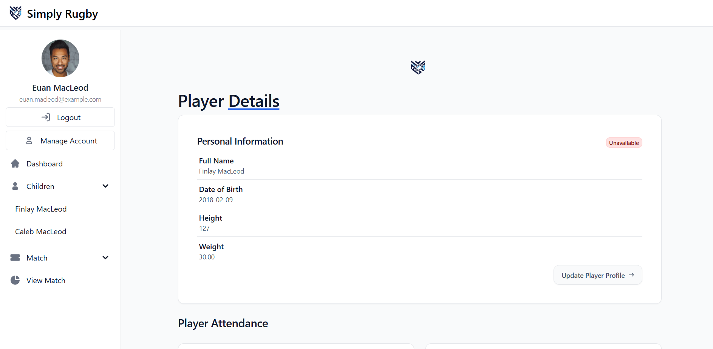
Figure 11
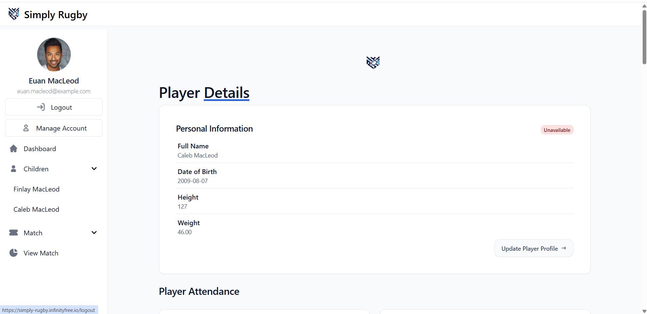
Figure 12
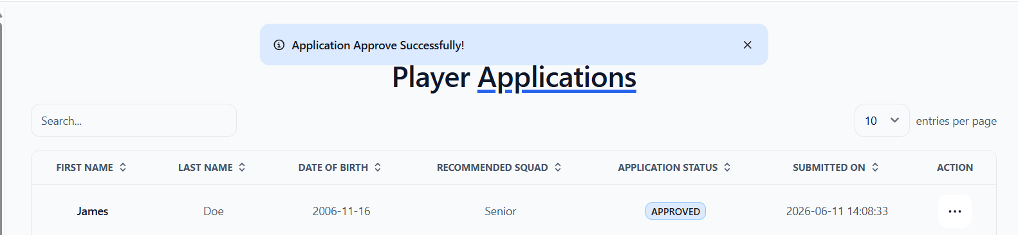
Figure 13
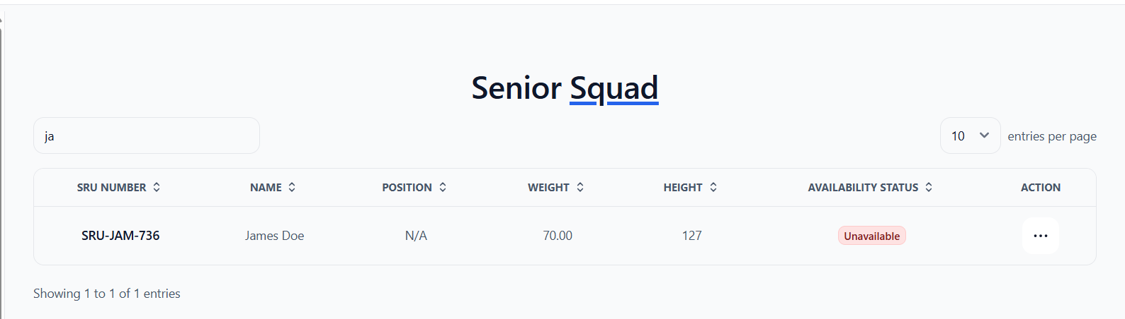
Figure 14

Figure 15

Figure 16
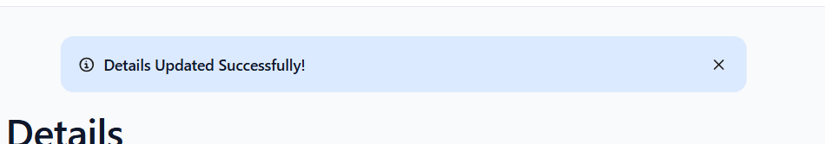
Figure 17

Figure 18

Figure 19

Figure 20

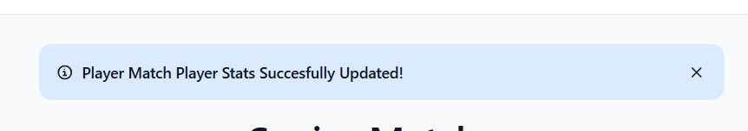
Figure 21

Figure 22

Figure 23

Figure 24

Figure 25

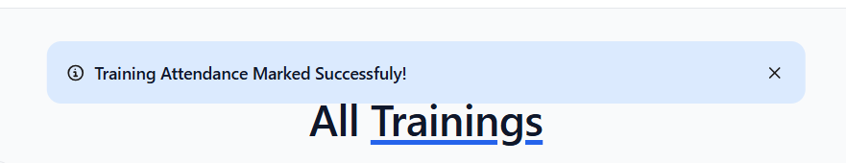
Figure 26

Figure 27

Figure 28
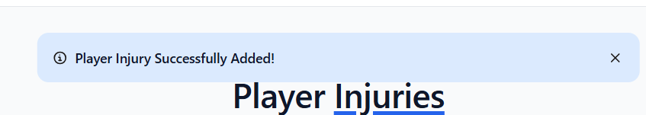
Figure 29
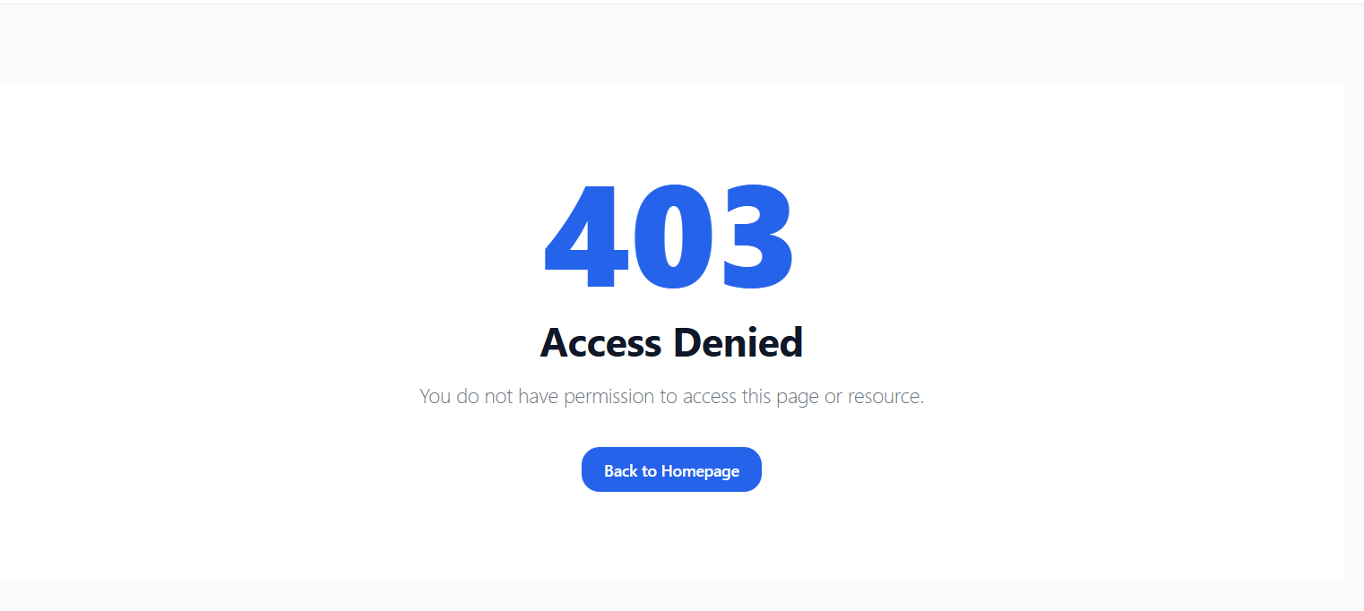
Figure 30
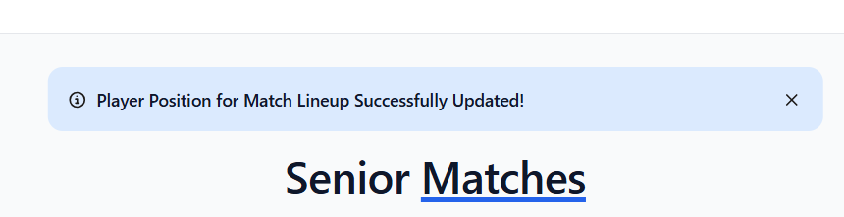
Figure 31

Figure 32

Figure 33

Figure 34

Figure 35

Figure 36

Figure 37

Figure 38

Figure 39

Figure 40 Parent

Figure 41 Coach

Figure 42 Coach and Parent

Figure 43 Fixture Secretary

Figure 44 Section Secretary

Figure 45 Senior Player
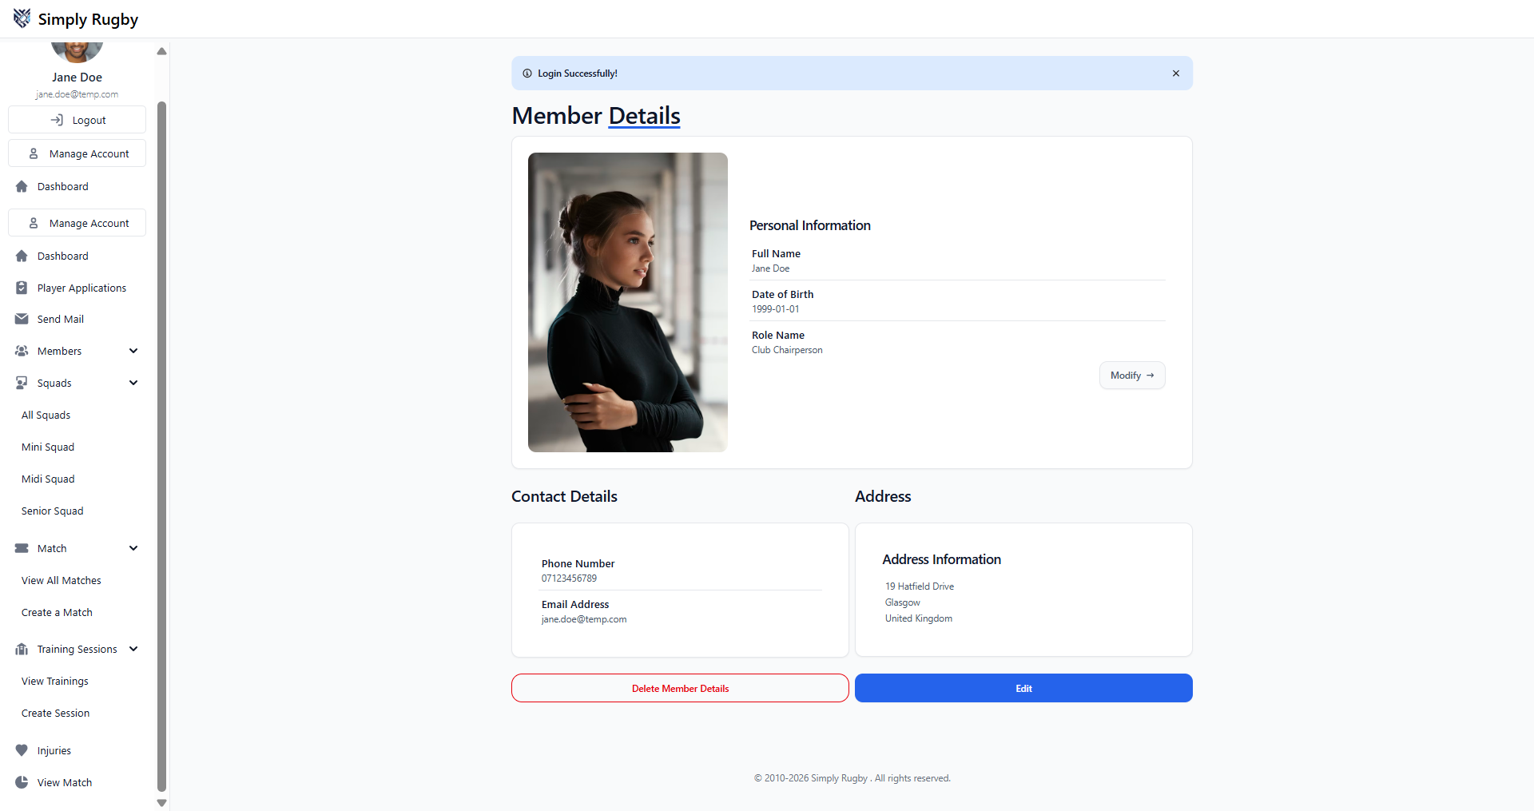
Figure 46 Club Chairperson

Figure 47 Membership Secretary

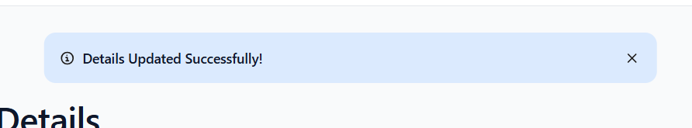
Figure 48
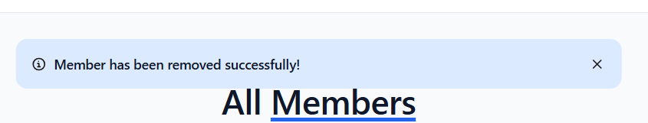
Figure 49
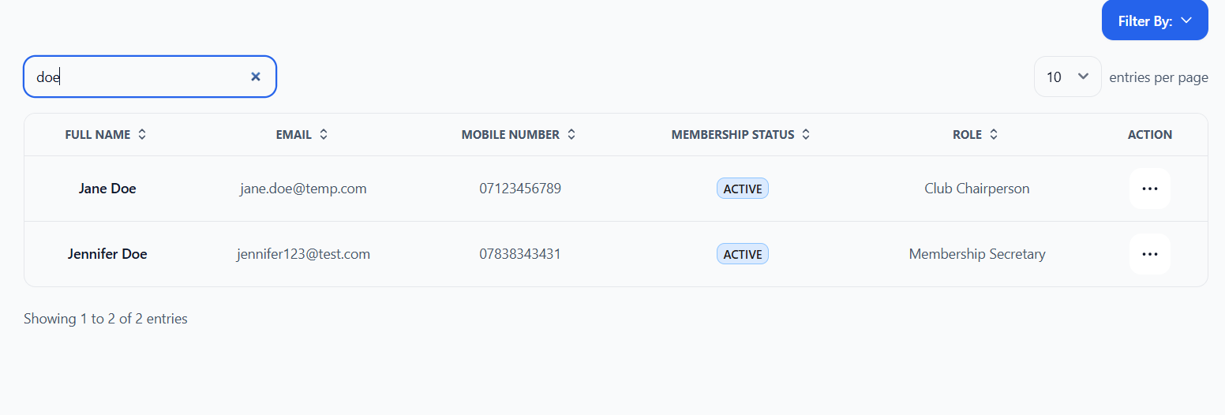
Figure 50

Figure 51
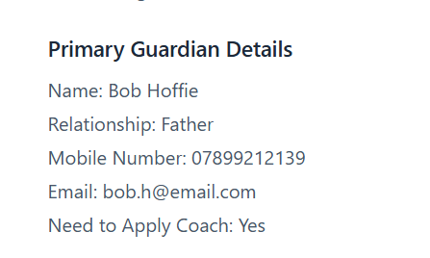
Figure 52

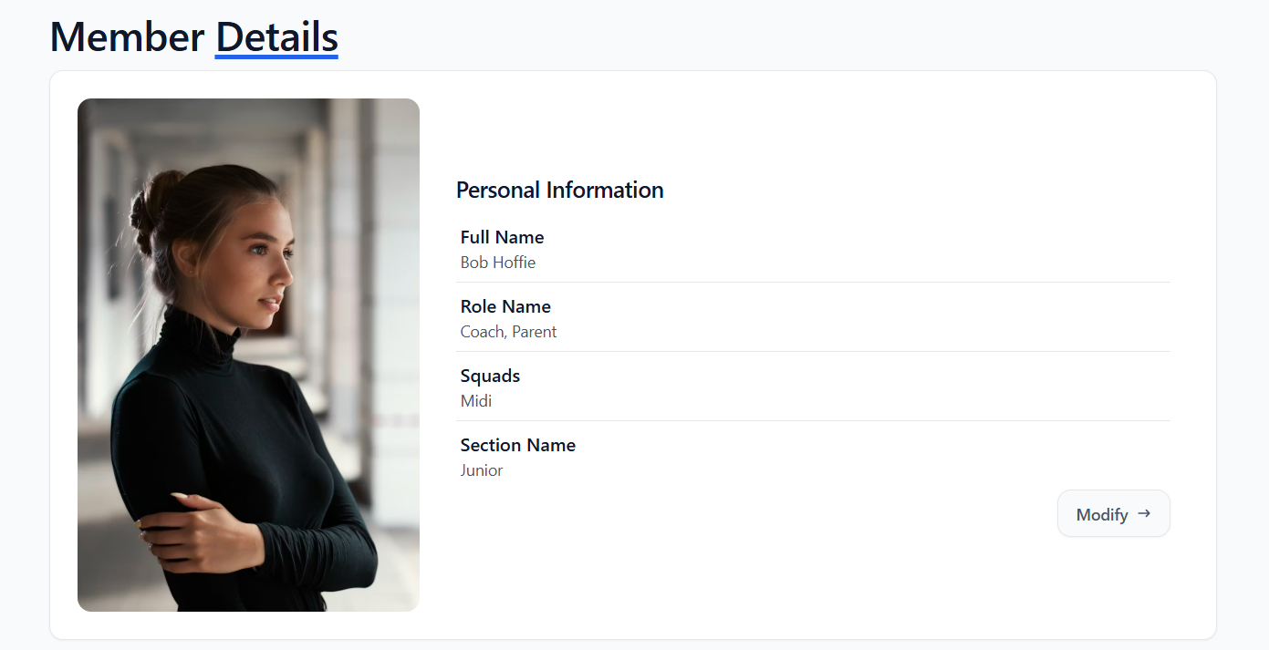
Figure 53

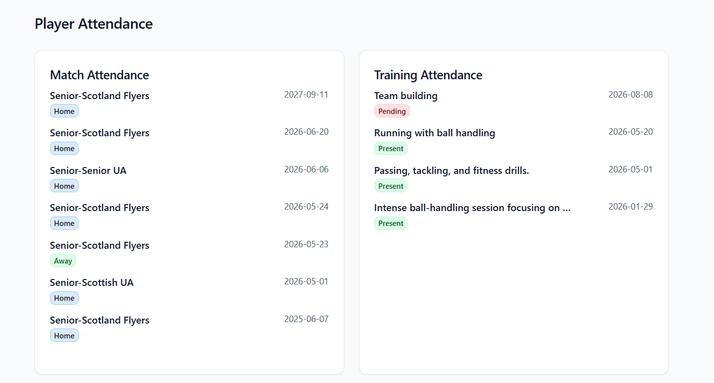
Figure 54

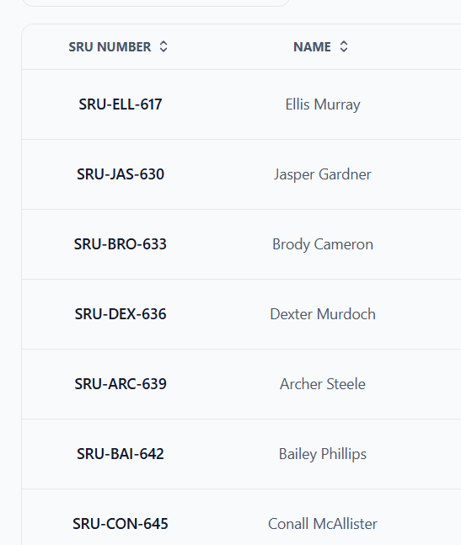
Figure 55

